Support request

Have you already visited our guide at sius.com/en/advisor? You will find many answers to questions you have already asked.
For a support request with immediate answer we need the following information:
In case of missing information or SIUS visit without advance notice, additional expenses can also be charged in case of warranty

- General information
- Contact person:________________________
- email: ________________________
- Customer No.: C-______________________
- Project Nr.: P-______________________
- Brief description of the problem:
____________________________________
____________________________________
____________________________________
____________________________________
____________________________________
____________________________________
____________________________________
____________________________________
____________________________________
____________________________________

- Used devices and serial number
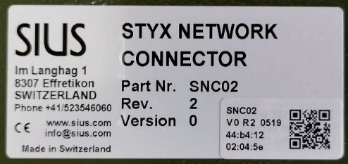
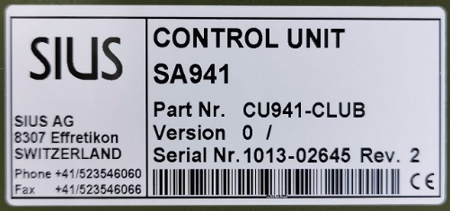
old generation new generation
min. Part No. and one serial No. each device type
  - Typ: ________ Serial No: __________
Software: __________
  - Typ: ________ Serial No: __________
Software: __________
  - Typ: ________ Serial No: __________
Software: __________
  - Typ: ________ Serial No: __________
Software: __________
  - Typ: ________ Serial No: __________
Software: __________
  - Typ: ________ Serial No: __________
Software: __________

- Test according manual
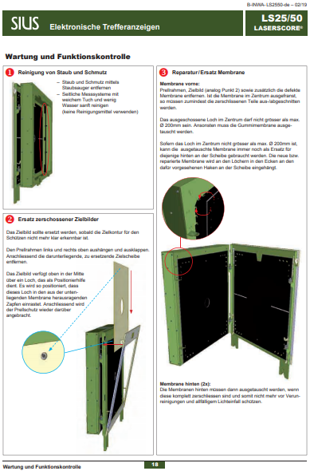
- Performing the tests according to the manual,
see "Installation, Start-up, Maintenance" at www.sius.com
-> Specification of the maintenance and tests performed with section number and page number
Test:
page: ____ section: _____
page: ____ section: _____
page: ____ section: _____
page: ____ section: _____
page: ____ section: _____
page: ____ section: _____
page: ____ section: _____
- Localization of the issue by swapping device
- Localize the issue by swapping the devices.
Attention: Do not forget to adjust the lane number of the devices (control unit, target, etc.).
Swapped:
device lane number issue stays at
device lane
______________ _____
______________ _____
______________ _____
______________ _____

- Printouts and self tests
- Actual printout, shoot
Insert picture here or attach to email
- Help prinout
  - Key: Help, Touch: System\ ”>>” (Next Window) \Help
  - Barcode
Insert picture here or attach to email
- Target test printout
  - Key: System\Maintenance\Self Test\ Target test
  - Barcode
Insert picture here or attach to email
- HexLOG
  - Key: System\Maintenance\Reports\Log\Log Hex
  - Barcode
Insert picture here or attach to email

- Test of Optical / Hybrid targets
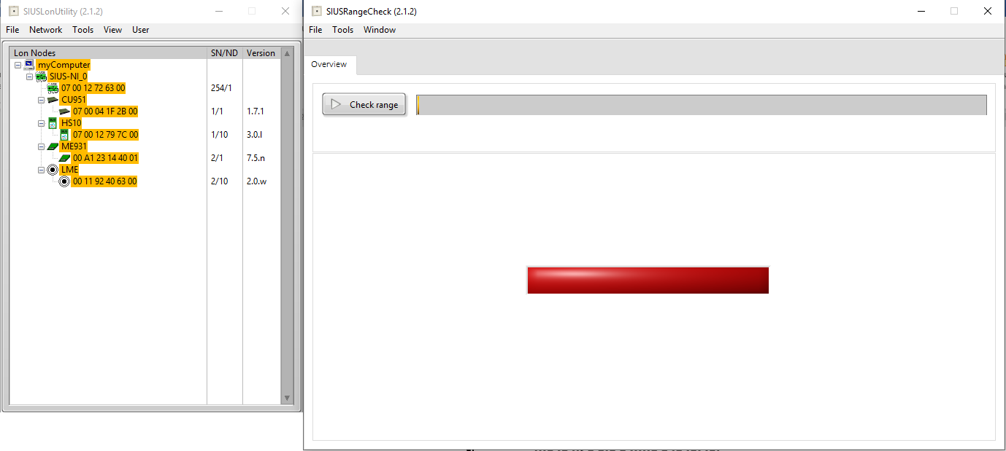
- LS10 / HS10 / HS2550 RangeChecker Data (excl. LS2550)
-> Download: software.sius.com
After the installation there is a manual available in the installation directory.
Attach file to email
- LS2550 Range Board data

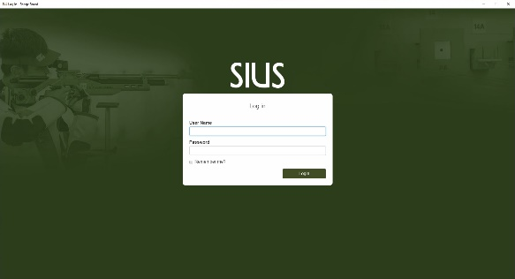

Start SIUS Cockpit

Login with
User Name: admin
Password: 282806
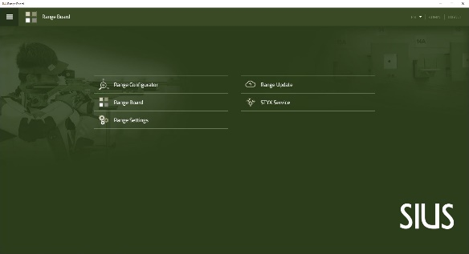

Select Range Configurator

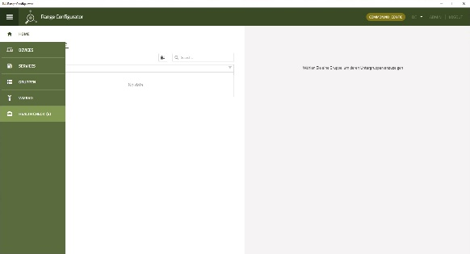

HEALTH CHECK

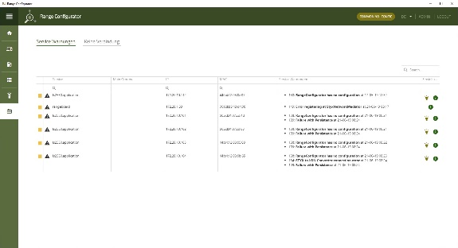

Screen copy

We need the screen copy of the states of the components
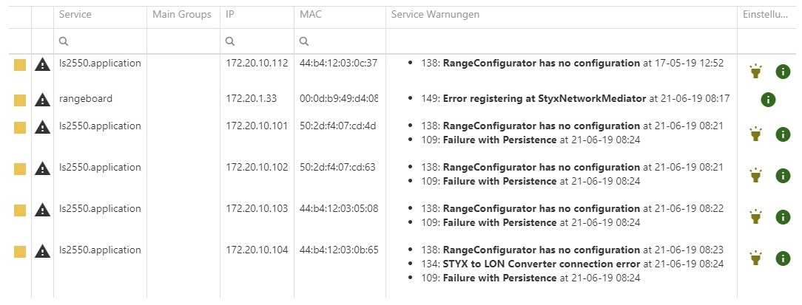

- Data of Programs
- SIUSRank
  - Copy of the database

- LED blinking code
- LED blinking code of the faulty device as video
Attach Video file to email or insert here as «drive-link»
- Range tour
- Range tour as video
Attach Video file to email or insert here as «drive-link»
- Photos
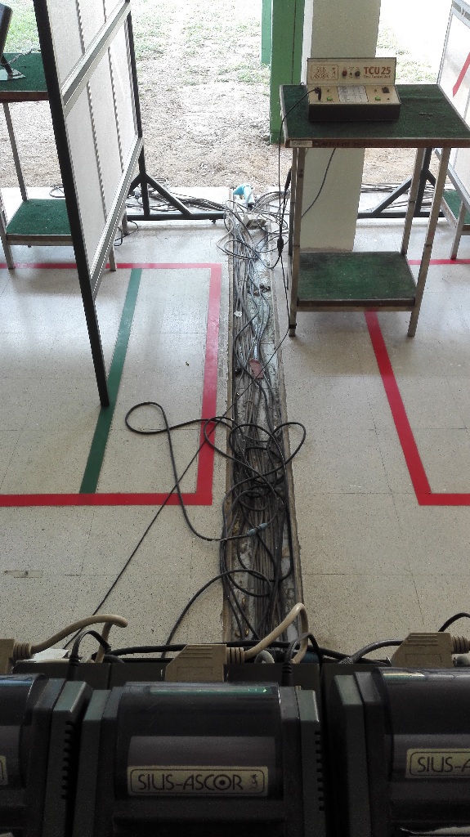
- Photos of the range and the cabling
What would we like to see? -> Replace these sample pictures with your own or attach them to email

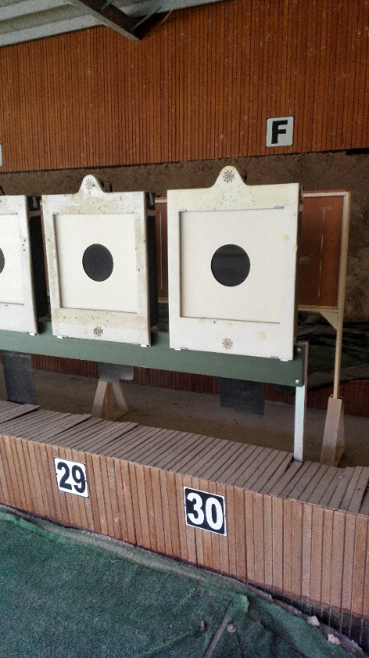
- Overview photos of the targets
What would we like to see? -> Replace these sample pictures with your own or attach them to email
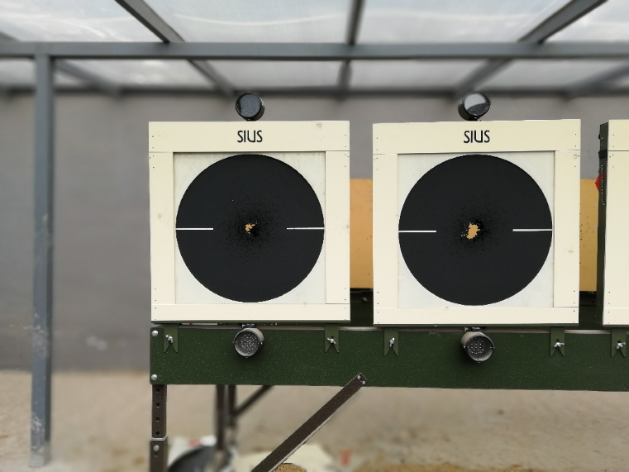
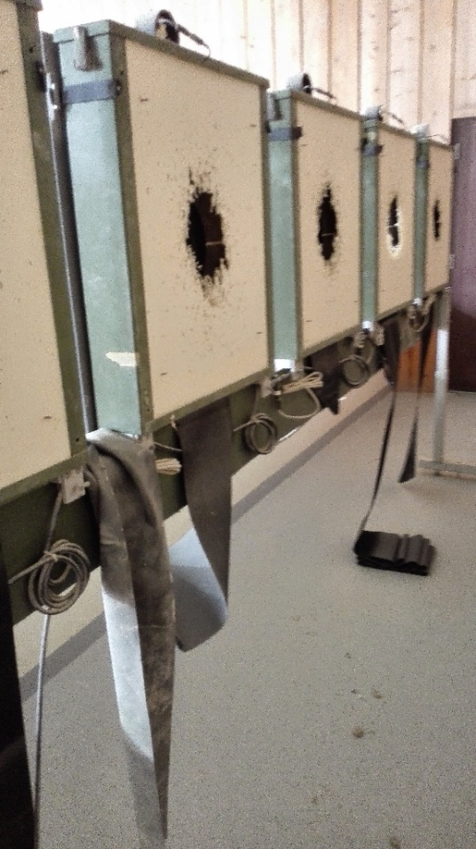
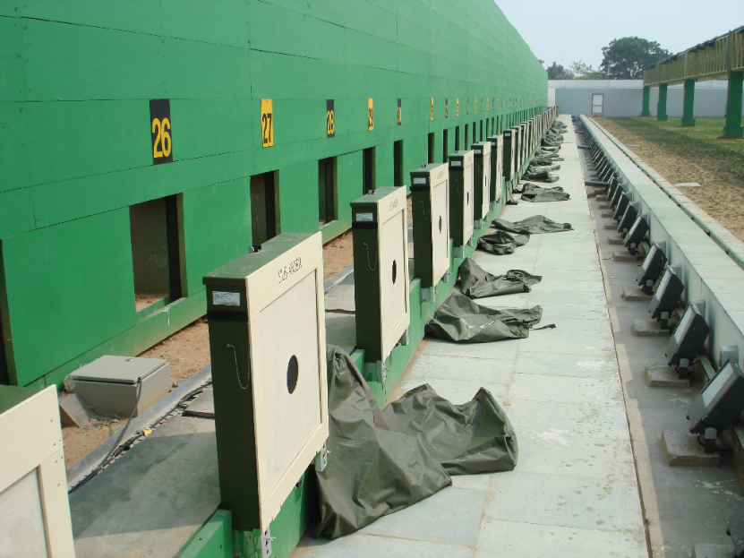
- Photos of the targets in detail
What would we like to see? -> Replace these sample pictures with your own or attach them to email
